**MC900048213[1]Algebra 2 Syllabus (including Grading Blueprint)**

Teacher: **Ms. Jeni Schultz**

Phone: **262-843-2321 Ext. 371**

Email: **schultz@westohsa.k12.wi.us**

**Course Description**

**Algebra II** reviews the major concepts of Algebra I and Geometry, and expands students’ understanding of properties of real numbers, operations, inequalities, algebraic expressions and graphing.  Complex numbers, conic sections, quadratic equations, relations, functions, exponentials and logarithms are also studied.

**Topic Outline**

**In Algebra II, the topics covered included solving equations and inequalities and graphing the following functions: linear, quadratic, polynomial, square root, rational, exponential and logarithmic. Conic sections are studied. The basics of Trigonometry are also covered such as finding angle measures and exact values and graphing the six trig functions. We conclude with solving oblique triangles and verifying identities.**

**To see additional content and student learning objectives for this course, please go to** [**www.westosha.k12.wi.us**](http://www.westosha.k12.wi.us) **and click on curriculum.**

**MCj03972100000[1]Required Supplies/Materials/ Technology**

**What do I need for Algebra 2?**

* a writing utensil, notebook & your agenda
* a binder (recommended)
* 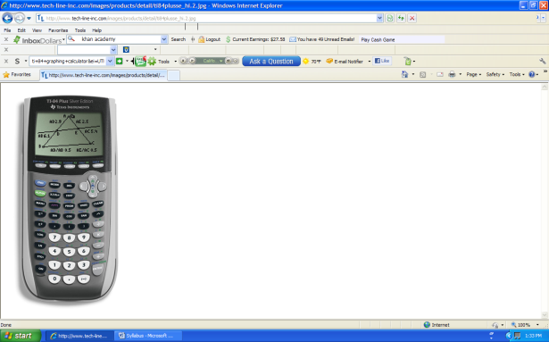a Texas Instruments graphing calculator *Avoid Casios!*

*Teacher Testimonial: I recommend the TI-84.* *I’ve had mine since I was a sophomore in high school & it got me through my advanced math courses in college. Therefore any TI grapher 85 & above, is not technically better; plus, I can’t assist you with any TIs greater than 84.*

* MC900195258[1]Internet access because…
  + - Moodle
    - There will be times that I will ask you to watch a presentation online via the Khan Academy: [www.khanacademy.org](http://www.khanacademy.org)
    - I’m online! [schultzjen.weebly.com](http://www.schultzjen@weebly.com)
* [](http://algebra2.com/)Last, but not least: a great attitude

**What is the Text?**

Glencoe McGraw-Hill textbook: Algebra Two.

**Website:** [algebra2.com](http://www.algebra2.com)

All the links you need can be found in the "Resources" menu to the left on the home page.  
This is also where you take the online "chapter readiness" or "self-check" quizzes. Also check out the "Additional Resources" for homework help and more!

**Grading Buckets**

Assignments are classified into categories (Grading Buckets) focused on the targeted learning of the course. Each bucket is weighted and contributes to the overall achievement grade. The weighted grading buckets for Algebra 2 are:

* Content Knowledge (10%)

Think…vocabulary, defining or describing; recalling information…

* Procedural Knowledge & Skills (60%)

Think…solving equations & inequalities; finding zeros; problems in which you evaluate…determine…find…solve…

* C:\Documents and Settings\SCHULTZ\Local Settings\Temporary Internet Files\Content.IE5\E0WR37BV\MC900048059[1].wmfApplications & Modeling (30%)

Think…solving word problems and graphing functions

**Course Grades**

Students will earn an Achievement Grade and a Life Skill grade for this course.

**Achievement Grade**

* **Achievement grades will be based on summative assessments,** which require students to demonstrate their understanding of the learning goals. A summative assessment occurs after a student has had the opportunity to practice, receive explicit feedback, and correct errors in learning or thinking.
* **Formative assessments** are practice opportunities that allow students to refine their understanding of new knowledge and skills without penalty. They occur during the learning process and provide students with specific feedback to inform their learning. They also provide teachers with feedback to improve instruction. **Formative assessments will not count toward the achievement grade.**

**Life Skill Grade**

* The Life Skills grade will be assessed using a universal rubric. Please see the attached rubric.
* Life skills will be recorded:

**Daily**

**Weekly**

**Bi-weekly**

|  |  |
| --- | --- |
| **Grade Descriptors** | |
| **A** | Students earning grades within the “A” range demonstrate proficiency **and** consistently exceed the standard. |
| **B** | Students earning grades within the “B” range demonstrate proficiency **and** at times exceed the standard. |
| **C** | Students earning grades within the “C” range demonstrate a proficient level of mastery of the targeted knowledge and skills. |
| **F** | Students receiving an “F” have not met the expectations for demonstrating the knowledge and skills as indicated by the learning targets within that course. |

**IMPORTANT –** Any ‘Procedural Knowledge & Skills’ or ‘Applications & Modeling’ assessment with a grade of 60% or lower will result in a mandatory retake. No grade will be put into Infinite Campus. Instead the assessment will be marked as “Missing” and a score of 0 will be calculated into your grade.

**Remember…you can retake assessments!**

**Opportunities for Reassessment**

Reassessment is done at the teacher’s discretion and must be completed within an acceptable time frame as defined by the teacher.Students meeting eligibility criteria will have the opportunity to retake specified assessments. The ability to reassess in this course is described below:

* **Which assessments?** Any “Procedural Knowledge & Skills” or “Applications & Modeling” assessments; there will be no retake offered on content knowledge assessments.
* **Eligibility criteria:** Your ticket to a retake will be a completed error analysis of the original assessment.
* **Time frame:** You have two weeks, upon receiving an assessment back to complete an error analysis and retake the assessment.

**Extra Credit is Not Allowed**

Grades are supposed to be measures of achievement, so it is appropriate that students have “extra” opportunities to improve their grades. Extra opportunities, however; must involve the demonstration of the knowledge and skills of the learning targets of the course. If these extra opportunities are to be valid, that is to raise a student’s grade from a C to a B for example; the additional demonstrations of knowledge and skills need to be at a higher level of achievement and not just more work to earn more

**Non-Negotiable Assessments**

A non-negotiable assessment is one that must be completed to pass the class despite the student’s grade average. The following are considered non-negotiable assessments in this course:

* n/a

**Missing Work**

Missing work whether due to excused absence or other reasons will be recorded as “Missing”, which calculates to a 0%.

**Absences**

Students who are absent from school shall be permitted to make up course work and examinations when they return to school**.** It is the student’s responsibility to contact his/her teachers to determine what course work and examinations must be made up. Teachers shall have the discretion to assign substitute course work and examinations, as well as to specify where and when examinations and course work shall be completed. The time for completing the work shall be equal to the length of the absence, unless extended by an administrator based upon extenuating circumstances.

**Self-Monitoring**

Students are expected to review their grades regularly in Infinite Campus. Students are also expected to check their email daily. If there is a discrepancy in a recorded grade, please communicate with the teacher.

**Classroom Procedures**

* **Leaving Class:**

It is the school’s policy that you must have your agenda in order to leave the classroom.

* **MP3s & IPods**

If there is time to work during the class period, you may listen to music so long that it is not disrupt others nearby AND you’re working.

All electronic devices should be stored away during instruction.